Problem Statement:

Predicting Survival in the Titanic Data Set We will be using a decision tree to make predictions about the Titanic data set from Kaggle. This data set provides information on the Titanic passengers and can be used to predict whether a passenger survived or not.

**Loading data and modules**

import numpy as np

import pandas as pd

import seaborn as sb

import matplotlib.pyplot as plt

import sklearn

from pandas import Series, DataFrame

from pylab import rcParams

from sklearn import preprocessing

from sklearn.linear_model import LogisticRegression

from sklearn.cross_validation import train_test_split

from sklearn import metrics

from sklearn.metrics import classification_report

from sklearn import tree

from sklearn.model_selection import train_test_split

titanic = pd.read_csv(‘https://raw.githubusercontent.com/BigDataGal/Python-for-Data-Science/master/titanic-train.csv’)

titanic.head()

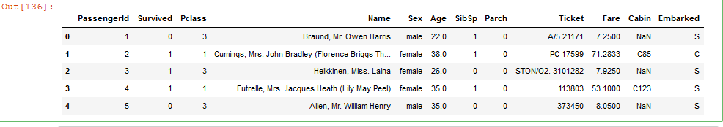

**###Make PassengerID as first column###**

titanic.set_index('PassengerId', drop = True, inplace = True)

titanic.head()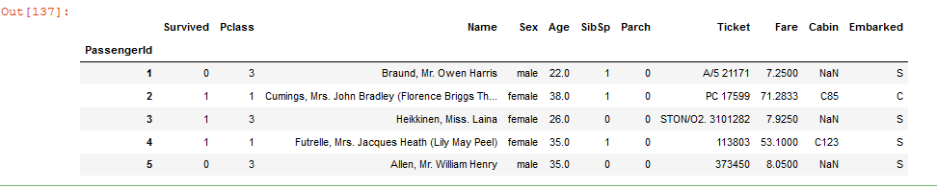

**##Delete Name colum##**

del titanic['Name']

titanic.head()

titanic['Embarked'].dropna(inplace = True)

titanic.head()

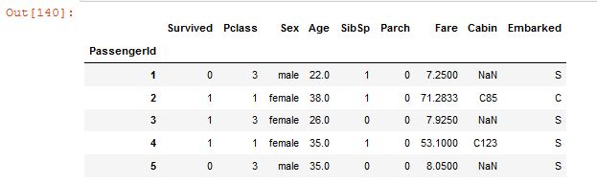

**##Delete Cabin column##**

del titanic['Cabin']

titanic.head()

**##Delete Embarked column##**

del titanic['Embarked']

titanic.head()

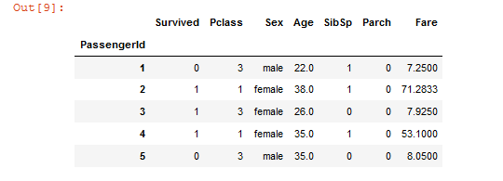

#numerical value for Sex in the column gender

def gender(st):

if st == 'male':

return 1

else:

return 2

titanic['gender'] = titanic.Sex.apply(gender)

titanic.head()

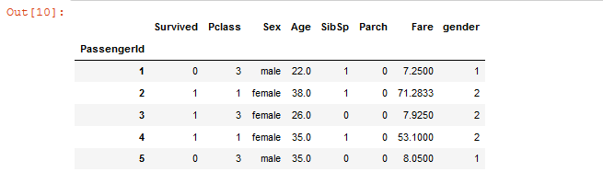

**##Delete Sex Column##**

del titanic['Sex']

**###Class 1 survival###**

class_1_surv = titanic[(titanic['Pclass'] == 1)].mean()['Survived']

class_2_surv = titanic[(titanic['Pclass'] == 2)].mean()['Survived']

class_3_surv = titanic[(titanic['Pclass'] == 3)].mean()['Survived']

class_1_surv

op7.PNG

**#graph based on class survival**

my_xticks = ['Class 1','Class 2','Class 3']

x = [1,2,3]

plt.xticks(x, my_xticks)

plt.plot(x, [class_1_surv, class_2_surv, class_3_surv])

plt.show()

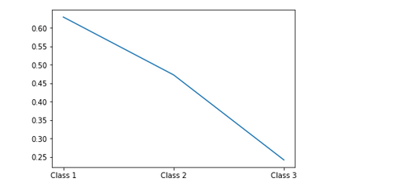

males = len(titanic[titanic['gender'] == 1])

females = len(titanic[titanic['gender'] == 2])

# male v/s female pie chart

plt.pie([males,females],

labels = ['Male', 'Female'],

explode = [0.10, 0],

startangle = 0)

plt.show()

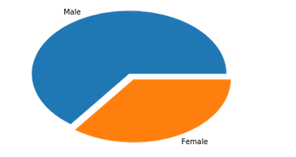

**#scatter graph based on age and gender**

plt.scatter(titanic['Age'], titanic['gender'])

plt.show()

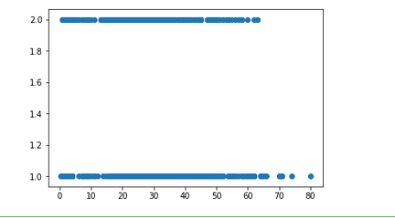

**##Average of survival**

survived = titanic[titanic['Survived'] == 1]

surv_avg = survived.mean()['Age']

not_survived = titanic[titanic['Survived'] == 0]

nsurv_avg = not_survived.mean()['Age']

def fillavg(survv):

if survv == 1:

return surv_avg

else:

return nsurv_avg

titanic['avg'] = titanic.Survived.apply(fillavg)

titanic.Age.fillna(titanic['avg'], inplace = True)

titanic.describe()

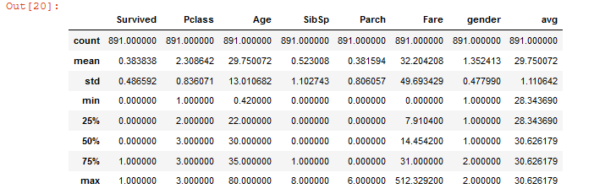

del titanic['avg']

titanic.head()

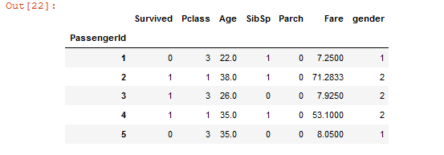

x_train,x_test,y_train,y_test = train_test_split(titanic.drop('Survived',axis =1),titanic['Survived'],

test_size = 0.30,random_state = 101)

**#Decision Tree**

clf1 = tree.DecisionTreeClassifier()

clf1.fit(x_train, y_train)

clf1.score(x_test, y_test)

op13.PNG